**Santosh Tamang**

**2147440**

**Exercise 1**

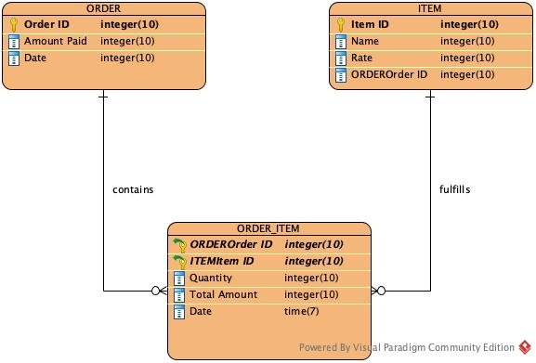

In this ERD, the entities are order and item. The attributes of the entity order are order id, amount paid and date. The attributes of item are item id, name, rate and the foreign key ‘orderorderid.’

The relation between the two entities is many to many. So, a third entity order_item is introduced. It contains the attributes quantity, total amount, date and foreign key from the major two entities. This ERD shows that an order may contain one or many item; whereas, one item may be ordered single or multiple times.

**Exercise 2**

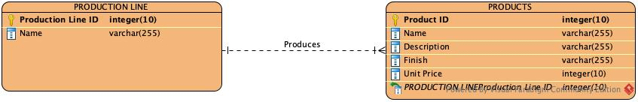

In this ERD, the entities are production line and product. The attributes of production line are production line id and name. The attributes of products are production id, description, finish, unit price and the foreign key.

The relation between the two entities is one to many. One production line may produce one or many products; whereas, one product may be produced by only one production line.

**Exercise 3**

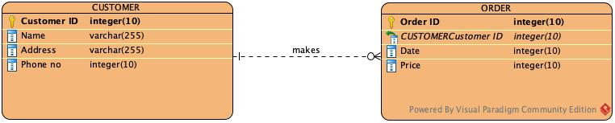

In this ERD, the entities are customer and order. The attributes of the entity customer are customer id, name, address and phone no. The attributes of the entity order are order id, date, price and foreign key.

The relation between the two entities is one is to many. A customer may make zero or many order ;whereas, one order can be made by only one customer.